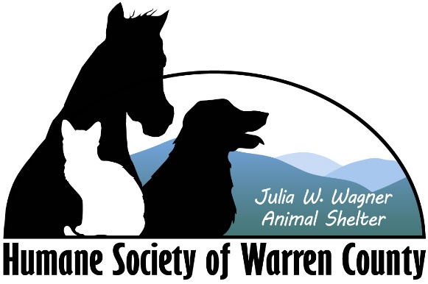

Humane Society of Warren County Intake Policy 2020

Animal surrenders are accepted through a managed intake system, requiring a pet owner to make an appointment to release their pet. Each owner fills out a comprehensive document, detailing the reason for surrender and information about their training, behavior and suitability for adoption.

We accept stray cats on a case by case basis, but do not accept feral cats. Aggressive dogs are accepted if and when we have the means to work with them.

We are contracted with Warren County Animal Control, and are under obligation to accept all stray dogs.