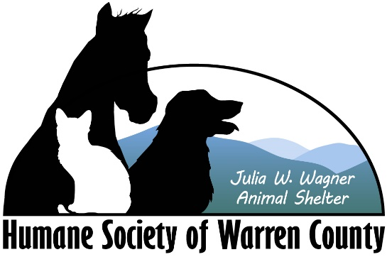

**Mission Statement**

The Humane Society of Warren County (HSWC) is a non-profit organization dedicated to providing compassionate care to abandoned, abused, homeless and neglected animals in our community. We aim to educate pet owners on the importance of vaccinations and population control and to place adoptable pets in loving homes.

**Goal Statement**

The goal of the Humane Society of Warren County is to provide compassionate and quality care to the homeless animals in our community. We aim to educate pet owners on the importance of vaccinations and population control and to place adoptable pets in loving homes. In 2011, HSWC began an aggressive campaign to increase adoption rates and decrease the rate of unnecessary euthanasia. By the end of 2012, the HSWC achieved no-kill rates. We aim to continue our advancements and become a model for others.

**Intake Policy**

The Humane Society of Warren County (HSWC) accepts owned animals on an appointment basis. This helps us manage the population in the shelter and allows to better prepare for what is coming in. When our kennels are full, we utilize a call down list. Owners help us save lives by waiting until we have the space. This also gives us time to work with the owners on resources for rehoming or training to prevent intake into the overcrowded shelter system. While HSWC is a private shelter, we do hold a contract with the County of Warren to operate as the county pound. The contract states that we will accept sick, injured, underage, and court case cats and dogs from animal control deputies, as well as stray dogs. Animal Control intakes do not require appointments.