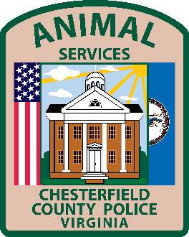

**Chesterfield County Animal Services**

**Intake Policy**

Chesterfield County Animal Services' shelter is a public shelter that impounds stray dogs running at large as defined in the Virginia State Code 3.2-6546 and those that have been deemed abandoned by their owner. Stray cats are impounded when they are determined to be sick or injured, are orphaned and unweaned, and/or have bitten/scratched an individual and are being placed on quarantine. Owner surrenders of dogs, cats, or other domestic animals are determined on a case by case basis.