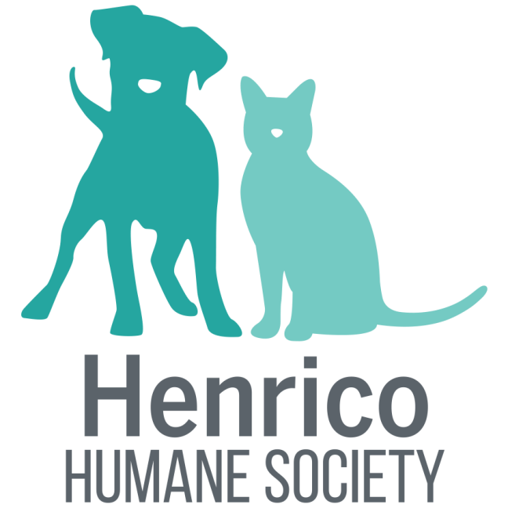P.O. Box 28014 Richmond, VA 23228 | (804) 262-6634 | henricohumane.org

Henrico Humane Society is a foster-based, non-profit organization that rescues dogs and cats from across Central Virginia and places them in loving, forever homes. We will take in surrenders as well as transfer animals into our organization on a case by case basis. We are an all foster organization so all animals are vetted as they need to be able to fit with a new forever family environment.

