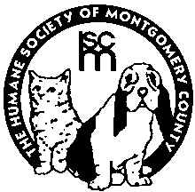
Humane Society of Montgomery County

1183 Flanagan Drive

Christiansburg, Virginia 24073

The Humane Society of Montgomery County accepts cats from the public as well as other Virginia releasing agencies. The HSMC is committed to saving the lives of homeless animals, with a focus on utilizing our resources to maximize the life-saving of companion animals to the greatest extent possible.

