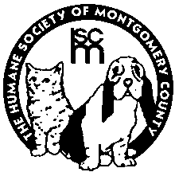**Humane Society of Montgomery County**

## 1183 Flanagan Drive

# **Christiansburg, Virginia 24073**

The Humane Society of Montgomery County accepts cats from the public as well as other Virginia releasing agencies. The HSMC is committed to saving the lives of homeless animals, with a focus on utilizing our resources to maximize the life-saving of companion animals to the greatest extent possible.