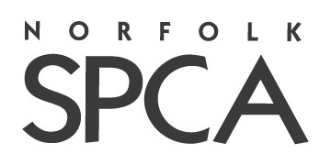

Norfolk SPCA Intake Policy

The Norfolk SPCA is committed to finding permanent, loving homes for each individual animal in our care. We take in over 1,800 animals annually. Animals accepted include owner surrendered animals from across the Hampton Roads region and transfers of animals from other local and regional shelters and rescue partners. We also accept animals through national partners to assist in disaster relief and emergency situations. Our goal is to reduce the euthanasia of healthy adoptable animals.

Animals are accepted as owner surrenders as space allows and by appointment. If no space is available, and an animal needs to be relinquished immediately, owners will be directed to their city contracted shelter or counseled on other options. All stray animals will be directed to the city's shelter in the jurisdiction where they were found. Incoming animals are evaluated and all animals that can be housed and managed with available resources are accepted. If an animal cannot be accepted based on its need for additional resources, owners will be counseled and alternative options with be provided.

Please note that while all efforts are made to place every animal into a home, the Norfolk SPCA recognizes that animals determined to have severe or unresolvable medical or behavior concerns will be compassionately and humanely euthanized to prevent further suffering.