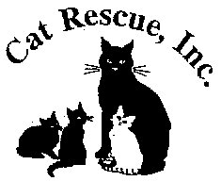
CAT RESCUE, INC.
1917 Benefit Road
Chesapeake, Virginia 23322-3025
(757) 237-6112

Cat Rescue Inc. Intake Policy:

Cats, kittens, moms and litters are accepted based on a variety of reasons. They can be transferred from other agencies/shelters, surrendered by owners and/or returned after being adopted.
Intake is based on available space/fosters/funding availability.

SHAWNE OWEN
President

