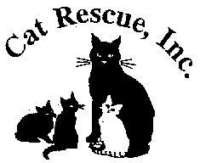
CAT RESCUE, INC.
1917 Benefit Road
Chesapeake, Virginia 23322-3025
(757) 236-6112

Cat Rescue, Inc.receives cats and kittens from the public, other Virginia releasing agencies, out-of-state agencies, and personal surrenders. Intake decisions are based on available foster homes and funding.

Facebook: Cat Rescue Incorporated Chesapeake
www.catrescueinc.com

Shawne Owen
President

