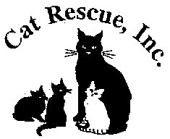

CAT RESCUE, INC.

1917 Benefit Road

Chesapeake, Virginia 23322-3025

(757) 236-6112

Cat Rescue, Inc.receives cats and kittens from the public, other Virginia releasing agencies, out-of-state agencies, and personal surrenders. Intake decisions are based on available foster homes and funding.

Facebook: Cat Rescue Incorporated Chesapeake

[www.catrescueinc.com](http://www.catrescueinc.com)

Shawne Owen

President