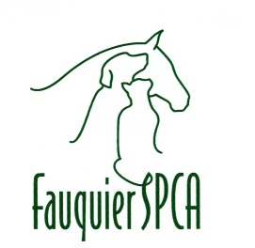

P.O. Box 733

Warrenton, Virginia 20188-0733

**\*\*\***

(540) 788-9000

Animal Intake Policy

Fauquier SPCA Private Animal Shelter

Animal intake policy of the Fauquier SPCA: Dogs and cats are accepted only as transfers from Shelters and Rescues are well as animals that are adopted from this facility and returned

In the event that our Fauquier SPCA(ACC) facility becomes filled then all animals that are unwanted by Fauquier County residents and strays that are found in Fauquier County are accepted.