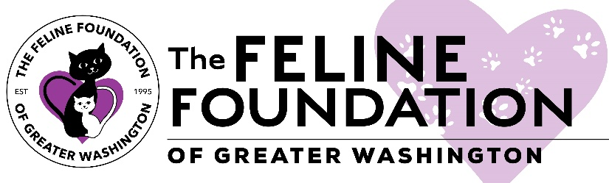

Feline Foundation of Greater Washington
Intake Policy

The Feline Foundation accepts cats and kittens from kill shelters, as well as found/strays from the local area and from good Samaritans. Each intake decision is based on available foster home space, and available funds as needed to address medical care of the cat. FFGW endeavors to never say no to a cat in need.

