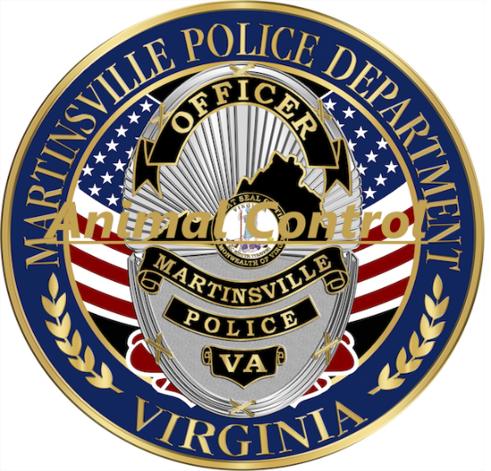

Intake Policy

Martinsville City Animal Shelter accepts all animals that appear to be in violation of VA Code 3.2-6503. We also accept owner surrenders when space is available. We also pick up dogs running at large within city limits.

