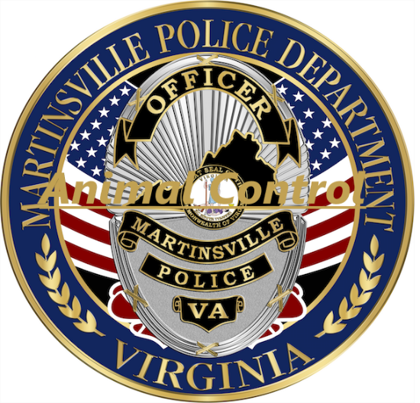

Intake Policy

We accept all animals that appear to be in violation of VA Code 3.2-6503. We also accept owner surrenders when space is available.