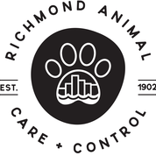
Intake Policy

Richmond Animal Care & Control (RACC) in an open admission municipal shelter. RACC takes in and provides care to any stray/abandoned/neglected animal in need in the City of Richmond. Owned pets from City of Richmond residents are accepted as surrenders by appointment because we will not euthanize for space.

