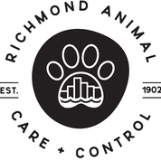

Intake Policy

Richmond Animal Care & Control (RACC) in an open admission municipal shelter. RACC takes in and provides care to any animal in need in the City of Richmond.