GENERAL ORDER Effective Date
NUMBER March 20, 2014

221. OPR Amends/Supersedes
August 1, 2012

SUBJECT: ANIMAL CONTROL CALLS

I. POLICY:

It is the policy of this Department to assist the citizens of the Town of South Boston in any law enforcement matters and to assist in other means to increase public safety. To these ends this agency provides an Animal Control Officer to respond to animal control calls. When this officer is unavailable other officers within the Department will handle these calls.

II. PURPOSE:

The purpose of this directive is to provide a procedure for response to calls for service to enforce animal control
laws.

III. PROCEDURES

A. Animal Control Officer (ACO) – On duty

The ACO will handle calls for service related to animals and enforce state and local laws, which regulate
animals within the Town of South Boston.

B. Recall of Animal Control Officer – After Hours, Days off and Holidays

1. The ACO may be called out by an officer (if possible after notifying the shift supervisor) for the following reasons:

a. Vicious animal which are a direct threat to public health and safety

b. Animals in custody that are injured or sick

c. Any emergency requiring the assistance of the Animal Control Officer

2. If the Animal Control Officer is not available for call out, on duty police officers will answer any calls for the ACO (in certain cases such as dangerous animals, animal bites, and abuse of animals the officer shall contact the Halifax County Animal Control Officers for assistance) including:

a. Vicious animals which are a direct threat to public health and safety

b. Animal bites (Incident Based Report must be completed); owner of the animal will be required under state law, to confine the animal for a ten (10) day period, this may be done via the local animal shelter or a licensed veterinarian, all at the expense of the owner. The owner may choose to confine the animal at their residence if there is no contact with other animals or people. All animal bites must be reported to the Health Department within 24 hours. All reports and a copy of the animal’s shots records (if obtainable) will be left for the Animal Control Officer to review.

c. Barking dogs

d. Animals in custody that are dangerous, sick, or injured. All other animal in custody calls will be
held until the next regular workday for the ACO. Callers with animals in custody will be advised they should take the animal to the local animal shelter, keep the animal detained (keeping it fed, watered, and in appropriate shelter) until the ACO next scheduled workday, or release the animal.

e. In those instances where a police officer is required to take an animal into custody (dangerous,
sick, injured, or in dangerous environment) the following procedures will be followed:

1. The ACO vehicle will be picked up and used to take the animal to the local animal shelter (if
they are open the officer shall turn the animal over to the Halifax County Animal Control
Officer on duty at the shelter, if the shelter is closed the officer will contact a Halifax County
Animal Control Officer for assistance with placing the animal in the shelter.

C. Paperwork utilized specifically for handling animal control calls

1. When placing a Department owned animal trap on a property the ACO or other officer will have the owner or person in control of the property sign an “Animal Trap Permission Form (Form 223.OPR 01)” agreeing to all conditions listed on the form. The ACO or other officer will release all animals caught in a Department trap but will not release animals caught in personal / private owned animal traps of citizens.

2. When the ACO or other officer is picking up a domestic animal from a residence / other privately owned property they will have the owner or person in control of the property sign an “Animal Surrender Form (Form 223.OPR 02)” agreeing to all conditions on the form.

3. The ACO shall document all animal control calls on an animal complaint form which shall be turned in to the Records Unit.

D. Process of designation of a canine as dangerous or vicious dog

1. When a canine has been deemed to be a dangerous dog by a judge of a Halifax County court there are numerous requirements by code 3.2-6540 (code of Virginia) and corresponding Town codes 18.81 – 18.90 that must be met by the person(s) owning the dangerous dog in order to keep the dog. For anyone living within the Town limits of South Boston going through the process of trying to keep a dangerous dog it is the responsibility of the South Boston Police Department to issue them a permit for a dangerous dog as long as they have met all requirements, the determination of their compliance with all requirements is the responsibility of the ACO. The owner of the dangerous dog must renew this permit with the agency each year, showing proof each time to the ACO that they are still meeting all requirements. When requesting a dangerous dog permit or renewing an already issued permit the owner of the dangerous dog much complete a “Request for Dangerous Dog Permit (Form 221.OPR 03)”. This form describes in detail the process that must be completed and requirements that must be met in order for a person to be issued a permit.

2. The ACO must handle a vicious canine in compliance with code 3.2-6540.1 code of Virginia.

AUTHORIZATION:

J. W. BINNER
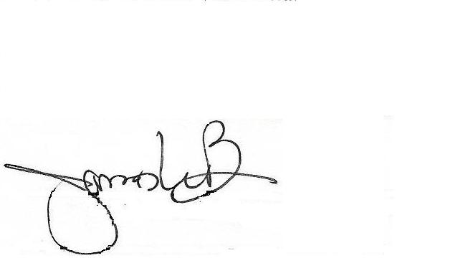
________________________________
CHIEF OF POLICE

