Mathews County Animal Control  
mathewscountyva.gov

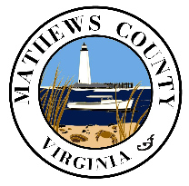

Mathews County Administration Telephone: 804-725-7172

50 Brickbat Road

Mathews, VA 23109

TO: Virginia Department of Agriculture

Ref: Animal Intake Policy 2024

Mathews County Animal Control Animal Intake Policy is guided by the Code of Virginia Title 3.2 Agricultural Animal Care and Food: Chapter 65 Comprehensive Animal Care. Mathews County Animal Control Officers are trained under code section 3.2-6556 requirements. Mathews County Animal Control Officers recognize the need to execute their duties for possible intake of all companion animals, agricultural animals, and wildlife abroad; henceforth dictated by Article 65 of the Code of Virginia regarding animal neglect, cruelty, abandonment, animal exposure reports and investigations, animal seizure cases, and injury. In addition to the Virginia Code, Mathews County Animal Control Officers are guided by Mathews County Ordinance 6-11, Animal Control Officer.

Chief Animal Control Officer, Misty Schwartz