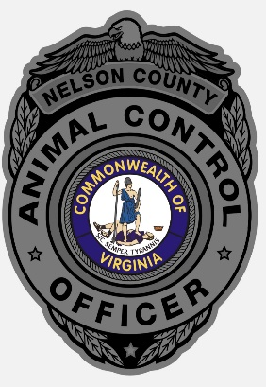

Nelson County Animal Control Intake Policy

Nelson County Animal Control operates a public shelter that intakes stray canines and injured or sick stray/feral felines found in Nelson County, Virginia. The shelter takes owner surrendered companion animals based on an individual case by case basis. The shelter intakes all seized companion animals for the County.

For Nelson County residents, the shelter is available for bite case quarantine and safe keeping of companion animals in extreme circumstances.

Stray, seized or owner surrendered agricultural animals are taken in through the shelter, but they are housed at outside facilities.

We do not intake wildlife.