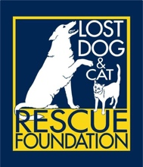

**INTAKE POLICY**

The mission of Lost Dog & Cat Rescue Foundation is to rescue dogs and cats from the threat of euthanasia at overcrowded shelters and from other at-risk situations.

In service of our mission, priority for intake is given to dogs and cats from our shelter partners. Intakes from shelters comprise more than two-thirds of our annual intake for both dogs and cats. We partner with shelters in Virginia and throughout the Southeastern United States as well as in Puerto Rico and other United States territories.

Owner surrender pets are accepted on a case-by-case basis as space allows.

Lost Dog & Cat Rescue Foundation accepts all breeds and breed mixes and all ages of dogs and cats.