**Emporia-Greensville Humane Society, Inc.**

**206 Industrial Drive**

**Emporia, Virginia 23847**

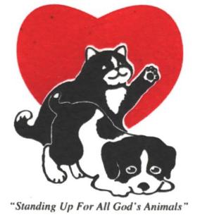

**INTAKE POLICY**

Emporia-Greensville Humane Society, Inc., herein referred to as EGHS or Society, will take custody of companion animals, dogs and cats, when they meet the standards as set forth herein.

The dog or cat must be friendly with no history of biting or having aggressive behavior. The Society will accept owner released dogs or cats. When, possible, proof of up-to-date vaccinations will be required at the time of intake.

All new intakes of dogs and cats will be quarantined until a wellness check by a licensed veterinarian can be performed, which will include all necessary vaccinations.

The Society will accept shy or timid dogs or cats if it is not an extreme case. The Society will work with these animals to resolve their issues in order for them to become adoptable.

The Society will not accept feral dogs or cats.

The Society will take animals from the animal control shelters when space is available and the animal meets the standards.

**STANDARDS:**

The Society WILL NOT take any dog or cat that has demonstrated aggressive behavior or history of biting.

The Society WILL NOT take any dog or cat with a serious health problem.

The Society WILL NOT take a cat or dog who is timid or shy to the point of needing a trained professional to overcome the problem.

The Society WILL NOT take feral dogs or cats.

All animals, before coming into the Society, will be met with and evaluated to determine if the animal meets the standards required. If intake standards are met, the animal will be accepted.

5-24-2004; revised 7-26-2023