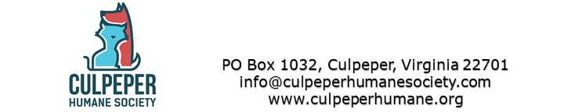

**Animal Intake Policy**

The Humane Society of Culpeper has a strict no-kill policy; which means that we will not euthanize animals, except if the animal is suffering and there is no hope for recovery. All animals are in dedicated, qualified foster homes for as long as necessary until adopted by a qualified applicant.

The Culpeper Humane Society intake policy is as follows:

* Transfer from the local county shelter (kill facility) for animals in imminent danger,
* Transfer from the local county shelter (kill facility) as needed ,
* Accept surrendered animals from members of the Culpeper County,
* Select animals from the VFHS’s High Five program from other Virginia Counties (kill facilities) as available foster homes allow, and
* Pick up stray animals after scanned for microchips and posting as a found animal.

We strive to take as many animals as possible, but have a limited number of fosters. Therefore we hold or attend adoption events almost every weekend and available animals are posted on Petfinder’s, which automatically updates our website and facebook pages.

Dogs and cats in Culpeper Humane Society’s foster program are fully vetted prior to adoption; spay/neutered, SNAP tested, UTD on core vaccines, wormed, deflead and microchipped. We strongly recommend the spaying and neutering of dogs and cats, in order to reduce the number of unwanted or surrendered pets in our area.