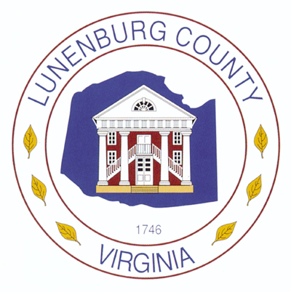

**Lunenburg County Public Animal Shelter Intake Policy**

Decisions on Animal Intake are based on the following:

1. Stray or Abandon
2. Seized
3. Bite Case Quarantine
4. Owner Surrender
5. Animals Received from another Virginia Releasing Agency
6. Other

Animals that Lunenburg County Animal Shelter does not take custody of:

1. Wildlife

Guidelines for Intake Policy are derived from State Veterinarian Prescribed Format (Instructions) for Animal Custody Reports, as well as Animal Custody Record 3.1-796:105.B of the Code of Virginia.