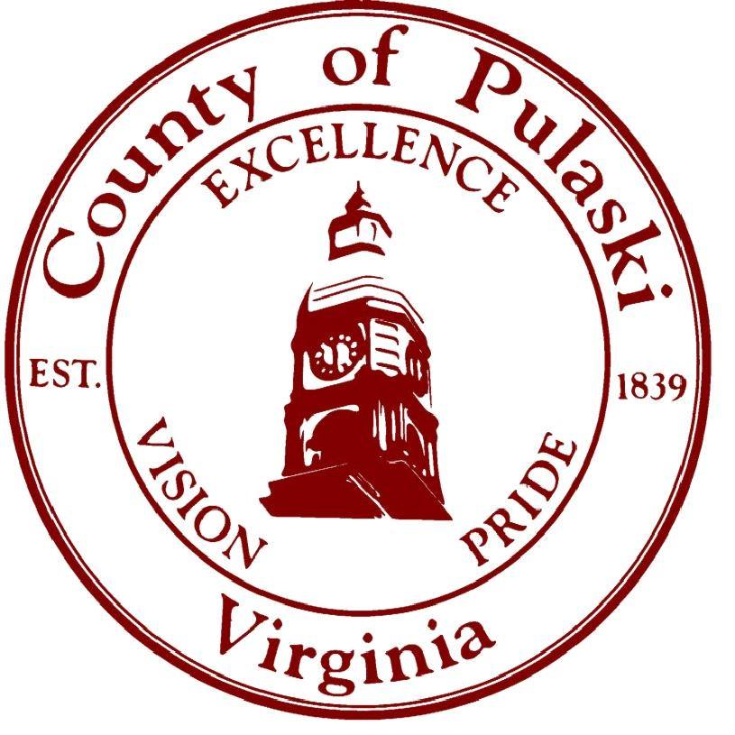

ANIMAL INTAKE POLICY

Pulaski County Animal Control will not accept any animals that are not from within our jurisdiction.

All animals that are accepted into the shelter will come in through Animal Control.

We will accept domestic animals, such as, but not limited to:

* Dogs
* Cats
* Rabbits and other small animals
* Poultry
* Livestock

Anyone having issues with wildlife will be directed to either the   
Department of Game and Inland Fisheries or a licensed wildlife rehabilitator.