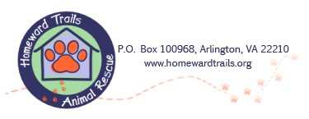

Homeward Trails Animal Rescue Animal Intake Policy

Homeward Trails Animal Rescue takes in animals from other Virginia releasing agencies, out-of-state agencies and owners who can no longer care for their pets. Homeward Trails Animal Rescue is committed to saving the lives of as many homeless animals as our organization’s structure and resources can safely and adequately support.

