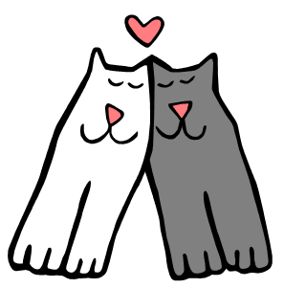
Commonwealth Cat Rescue, Inc.

January 2024

Intake Policy

To whom it may concern:

This is to certify that all our intakes are on a case by case basis, except bite cases which we do not accept, likewise, strays which we refer to animal control, and any animal, cat or dog which we believe would not be suitable for a typical family.

Best Regards

Chris C. Haslam

Chris C. Haslam
President

11837 Waples Mill Road – Oakton, VA 22124

