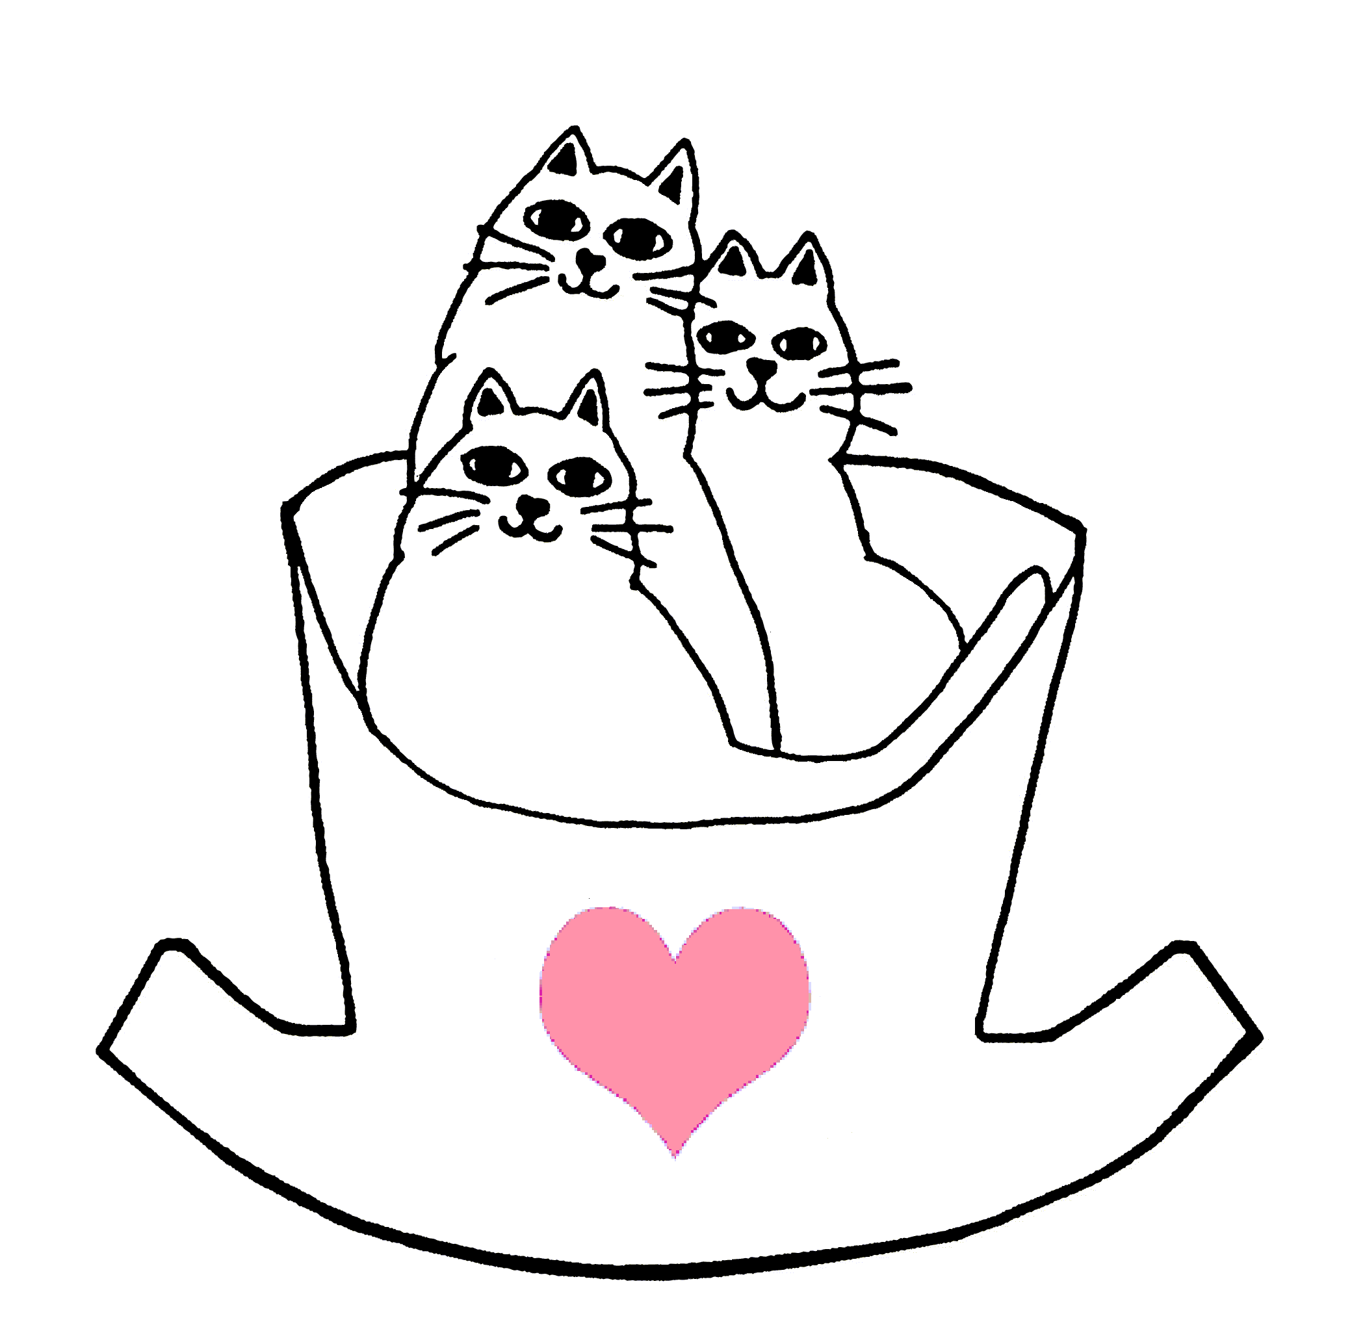
Cat’s Cradle of Greater Richmond, Inc.
“We’re safe now.”

P.O. Box 70040
Richmond, VA 23255-0040
CatscradleRichmond@gmail.com
www.catscradlerichmond.com
www.petfinder.com

Mission Statement and Intake policy

Cat’s Cradle of Greater Richmond is a 501(c)(3) non-profit volunteer organization committed to the rescuing of cats and kittens regardless of appearance, age, or medical condition from euthanizing shelters and abusive or neglectful situations. Cat’s Cradle of Greater Richmond provides spay and neuter and all other necessary veterinary care, and furnishes comfortable, attentive housing until each cat or kitten is adopted into a permanent, loving home. Cat’s Cradle of Greater Richmond is supportive of all animal advocacy organizations and all efforts to reduce animal cruelty in any form.

Our feline intake policy includes:

- Strays/Abandon: Note: for any animal considered to be homeless who is entering our program, we will always make reasonable efforts to identify the owner.

- Owner Surrenders: Relinquished pets are evaluated and accepted on a case by case basis, pending available foster space.

- Transfers from Public and Private Animal Shelters in Central Virginia: Note: Animals transferred from these various agencies area accepted by priority and on space/funds available basis.

