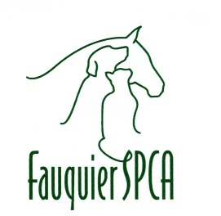

P.O. Box 733

Warrenton, Virginia 20188-0733

**\*\*\***

(540) 788-9000

Animal Intake Policy

Fauquier SPCA Animal Shelter (ACC)

Animal intake policy of the Fauquier SPCA(ACC): All animals that are unwanted by Fauquier County residents and strays that are found in Fauquier County are accepted. We also accept transfers from Shelters and Rescues that are overwhelmed. We do not accept wildlife except from Fauquier County Animal Control.