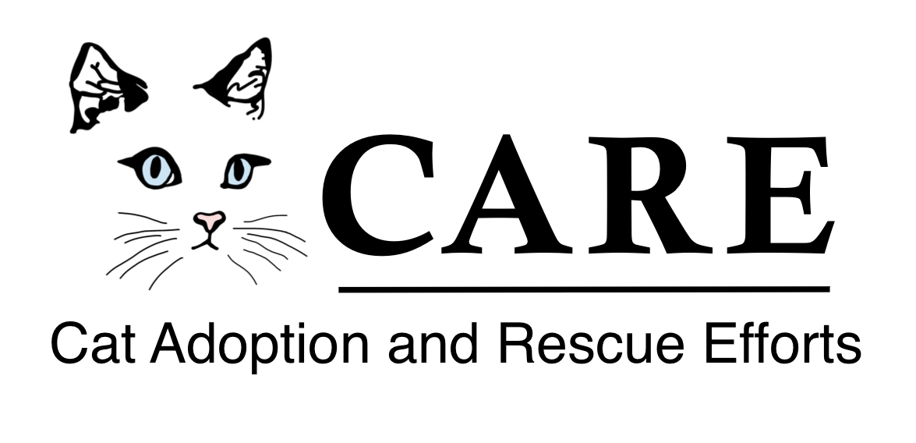

Cat Adoption and Rescue Efforts, Inc.
Feline Intake Policy
January 1, 2020

CARE Mission Statement
Cat Adoption and Rescue Efforts, Inc. (C.A.R.E.) is an all-volunteer, non-profit 501 (c) (3) organization dedicated to the rehabilitation, care and adoption of cats and kittens rescued from euthanizing animal shelters in Richmond, VA and surrounding areas. And, accepts on a limited basis animals from alternative sources. We are committed to the highest principles of humane care and obtain professional medical treatment for all animals in our systems.

Intake Procedures
- All felines are assigned an ID number and a CARE foster.
- The foster is responsible for safe housing and ensuring the feline receives medical care and appropriate food, water and socialization.
- All felines are to be quarantined from other animals for a minimum of 72 hours.
- All felines are to be immediately examined by a licensed veterinarian, checked for a microchip, tested for FeLV/FIV and given age appropriate vaccines.

Shelter Intake
- All felines are assessed for temperament, health, behavior and suitability as an indoor pet by the CARE intake coordinator prior to acceptance.
- CARE does not accept aggressive or feral cats and refers community members to organizations that assist with feral cats.
- CARE accepts a limited number of severely ill animals if there is a suitable foster that can provide the required care.

Stray Intake
- Community members are directed to report the stray feline to their local animal control and to check local laws on stray periods, along with making a good faith effort to find its legal owner by asking neighbors and posting notices on community websites and social media. If after notifying the local animal control, the stray period has passed and no owner has been found, Care will consider intake after assessment and if a foster is available.
- Strays are taken in immediately only in the following circumstances: young kittens, whose mother is known to be deceased, or felines who have knowingly been abandoned.
- All stray felines are to be immediately examined by a licensed veterinarian, checked for a microchip, tested for FeLV/FIV, and given age appropriate vaccines.

Surrender Intake
- CARE accepts return felines if they were originally rescued and adopted out by CARE. The feline must have been examined by a veterinarian within the past 6 months, be altered, current on its vaccines and retested negative for FeLV/FIV. A veterinary report is required. The owner is required to fill out information on the feline and sign a surrender form that relinquishes all ownership rights.
- Other surrender felines are taken in on a limited basis.
- Surrender Donation: $100 per feline plus any additional required medical fees.
P.O. Box 2934 Henrico, VA 23228 804-288-9797 www.care-cats.org

