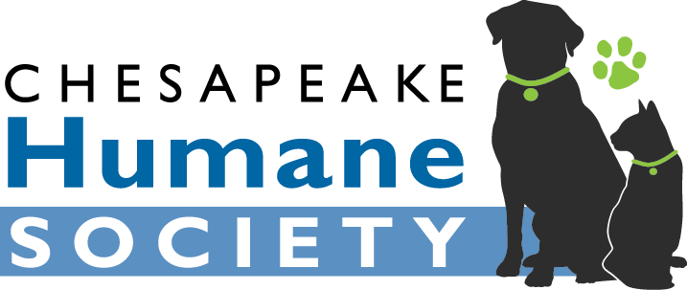
SOP: Intake of Animals
Revised 01/08/2019

- Types of animals accepted
Chesapeake Humane Society (CHS) routinely accepts domestic felines and canines. CHS does not accept wild animals, exotics, pocket pets, rabbits, birds, livestock, horses, etc as our facility lacks the appropriate housing, resources, and trained staff to care for and place these animals. An exception may be made for pocket pets or birds at the discretion of the Medical Director if an appropriate foster home and resources required for care are available.
- Transfer of animals from outside organizations
The majority of CHS animals are transferred from Chesapeake Animal Services (CAS), but animals may be accepted from other organizations as space allows. Priority is always given to CAS pets. Transfer candidates are assessed for temperament and wellness prior to intake.
Animals exhibiting the following are typically not transferred to CHS:
- Severe aggression toward humans or other animals
- Severe medical issues
- Contagious, difficult-to-treat illnesses such as ringworm or sarcoptic mange
- Unresolved litterbox issues
- Advanced age (12+)
Exceptions may be made at the discretion of the Medical Director and/or Office Manager.
- Adoption Returns
CHS will accept pets adopted from the organization at any time without condition. If the pet is not suitable for adoption due to medical/behavioral concerns, the Medical Director and Office Manager will determine an appropriate disposition for the animal following intake.
- Owner Surrendered Animals
Citizens from the city of Chesapeake that are in need of rehoming services for their pets should be directed to CAS. If space allows, CHS may agree to accept owner surrendered animals on a case-by-case basis. Intake candidates are assessed for temperament and wellness prior to intake.
Animals exhibiting the following are typically referred to other organizations:
- Severe aggression toward humans or other animals
- Severe medical issues
- Contagious, difficult-to-treat illnesses such as ringworm or sarcoptic mange
- Unresolved litterbox issues
- Advanced age (12+)
Exceptions may be made at the discretion of the Medical Director and/or Office Manager. CHS will make every effort to provide any owner in need of rehoming services with resources, alternatives, and rescue/releasing agency referrals if appropriate. Pets originally adopted from other local organizations should be returned there unless the releasing agency specifies otherwise.
- Strays
All strays must be delivered to the animal control agency for the city in which they are found. If a client is unable to bring the pet to the city agency, CHS may temporarily hold the pet until animal control from that city is able to pick it up.
CHS will make an exception for un-weaned kittens if a foster home is available. These intakes are reported to the animal control agency for the city in which they were found and taken into custody with the permission of that agency.

