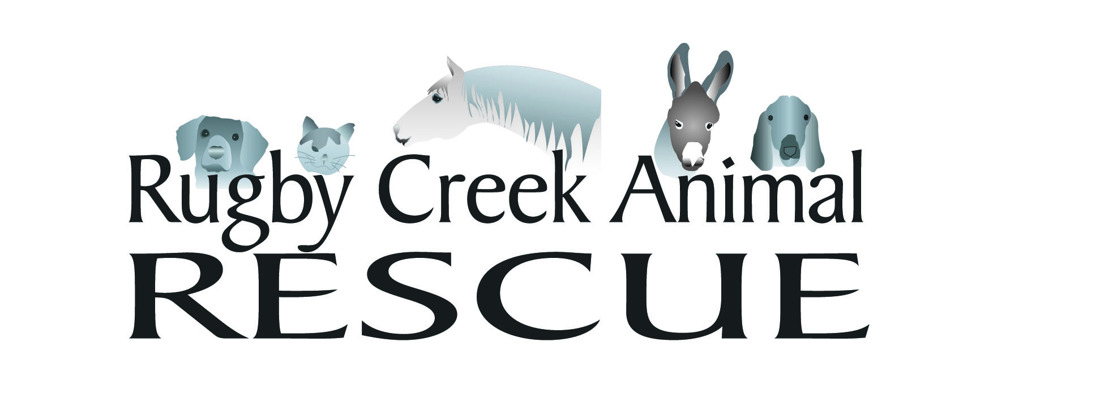

Intake Policies

Rugby Creek Animal Rescue, Inc is hereinafter referred to as RCAR.

RCAR will only accept animals into its care that are approved by at least one member of its Board of Directors.

RCAR does accept domestic dogs and occasionally cats
RCAR does accept farm animals such as goats, donkeys, sheep, occasionally a small pig
RCAR does accept horses of all breeds, ages, gender and type

RCAR does not accept any type of wildlife except to the affect of temporary custody to transport wildlife in need to an approved official Wildlife Rehabber or Rehab Facility.

RCAR does not accept fowl (ducks, geese, birds etc) except to the affect of temporary custody to transport the fowl to an approved Fowl Rescue or Rehab Facility.

Most animals are received into RCAR by Owner Surrender or being pulled from a nearby Animal Control Facility. We do occasionally accept stray horses and hold until released from the County.

RCAR also provides temporary Quarantine and Foster Care for animals being transferred out to other Non-Profit Animal Rescues.

RUGBY CREEK ANIMAL RESCUE, INC
501 © 3 Non-Profit

276-579-4215
www.rugbycreekanimalrescue.org

1314 Rugby Road, Mouth of Wilson, VA 24363

