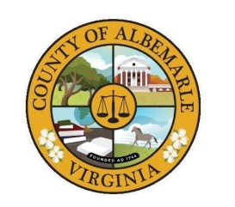 | COUNTY OF ALBEMARLE  Police Department  1600 5th Street, Suite D  Charlottesville, Virginia 22902  Phone: (434) 296-5807 • Fax: (434) 972-4061 | 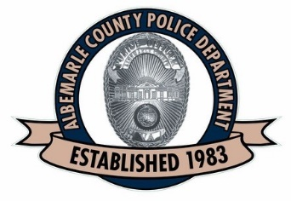

The Animal Protection Unit personnel shall render services and assistance to citizens upon request regarding domestic animals and, on occasion, wildlife.

APU Supervisor Mason Walsh
AP301, ACPD
434-296-5807x3980

