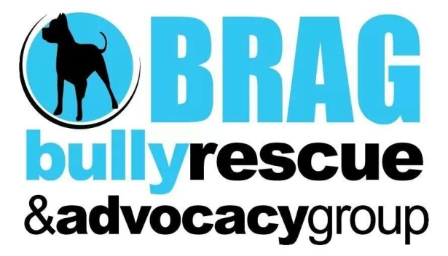
Bully Rescue & Advocacy Group will take in dogs and cats from any situation we see fit. These animals are then adopted out into the community.

