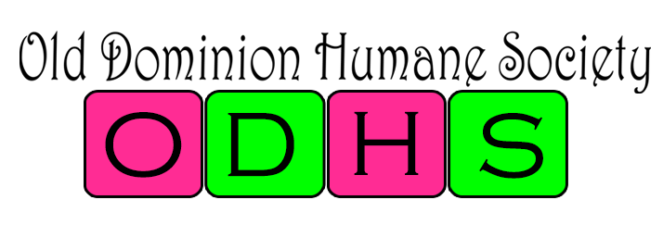
March 15, 2023

Intake Policy for Old Dominion Humane Society

This private animal Shelter intake policy is as follows:

Old Dominion Humane Society will only intake dogs.

Reasons for Intake include:
- To Alleviate overcrowding in County Shelters
- To prevent Owner Surrenders to overcrowd county Shelters
- Regain Custody of Dogs that have been in ODHS Custody in the past - Return of ODHS Alumni Dogs

Old Dominion Humane Society WILL NOT take in strays or dogs that have no clear ownership. All “found dogs” or “strays” will be referred to the county the dog is found in. That county is required to keep the dog for the stray hold required for that particular jurisdiction before Old Dominion Humane Society will accept. Old Dominion Humane Society will then pull that dog from that particular jurisdiction in accordance with their pull procedures.

Policies in place once custody has been determined:
- All incoming dogs will be required to have a Da2PPV and then placed in a quarantine status for 3 days after vaccination.
- All dogs need to pass a temperament test and dog evaluation, completed by Chrissy Blake or an appointed personnel.

Chrissy Blake
Director

