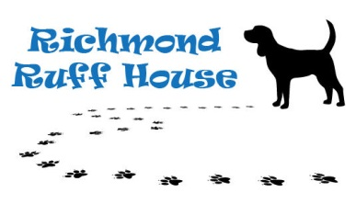

**INTAKE POLICY**

Richmond Ruff House receives numerous requests every month to take in dogs. Unfortunately, we cannot safely or humanely accommodate every request and are limited by the number of volunteer foster parents we have on any given day.

Richmond Ruff House has a strict no-kill policy; which means that we will never euthanize one animal to make room for another. RRH's policy is to help dogs in the most dire need first. We sincerely regret not being able to take an animal. However, when our foster homes are full, we have no choice but to offer other options such as referral to another shelter/rescue or assistance with a courtesy post so that you may place the animal yourself.

We accept the following animals (in this order)

1. Transferred from Richmond City and surrounding county Animal Control/Shelters
2. Transferred from counties outside of Central Virginia
3. Owner surrenders as space is available

We DO NOT accept the following animals

1. Strays
2. Animals outside of Virginia (except in the event of a natural disaster and MUST be approved by the Board)

We try our very best to take in as many dogs as we possibly can every month but we ask for your understanding when we are full and have nowhere to house any more dogs. Overcrowding creates stress on the animals, the volunteers and causes spread of disease. In addition, overcrowding is illegal and inhumane.

Richmond Ruff House encourages the community to aggressively promote spaying/neutering of all companion animals to help eliminate the crisis of animal overpopulation.