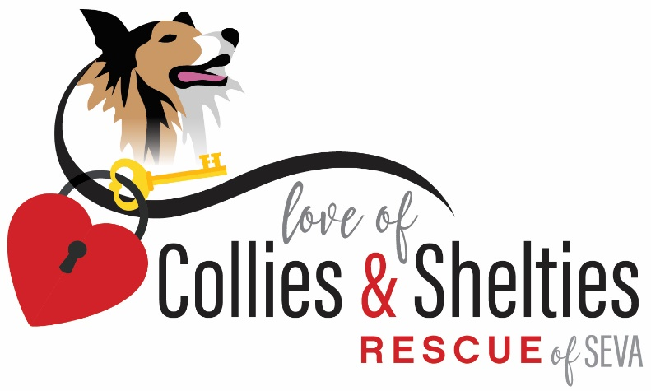594 Colony Road

Newport News, VA 23602

[karen@locsofseva.com](mailto:karen@locsofseva.com)

<https://loveofcolliesandsheltiesrescue.com/>

757-814-4389

Love of Collies and Sheltie Rescue hereinafter referred to as LOCS Rescue and formerly known as Collie and Sheltie Rescue of SEVA is a non-for-profit volunteer organization, 501(c)(3) [Tax ID# 54-1812331] that was established over 25 years ago. LOCS is dedicated to the rescue, rehabilitation, and rehoming of purebred and mixed Collies and Shelties regardless of age or medical condition. LOCS does not accept dogs with a known history of unprovoked biting due to liability.

The dogs surrendered to LOCS come directly from owners who must relinquish their pets for various reasons, other Virginia releasing agencies, and occasionally from out of state agencies. LOCS provides immediate veterinary care that includes a wellness exam, updating vaccinations, heartworm testing and prevention, treatment for fleas/ticks and prevention, microchipping, spaying, or neutering, and dental work if necessary. After appropriate veterinary care is provided, the dog is placed in a foster home where their likes, dislikes and quirks are evaluated. Foster homes serve a crucial part in evaluating the dog and finding the right home for that individual dog. LOCS is committed to the veterinary care and expenses of the dog until the dog is placed. LOCS’s goal is to find the right match between the dog and his or her forever home. LOCS makes a commitment to keeping in touch with all adopting families.

LOCS makes a strong attempt to educate the public about the Collie and Sheltie breed through adoption and community outreach programs. By educating the public on the importance of veterinary care and serving as a reputable resource for information on responsible pet care, LOCS is committed to serving the community. In addition, LOCS offers pet sitting for the adopted dog when possible.

Prospective foster families and board members must fill out an application and be approved prior to volunteering. LOCS requires a veterinarian reference check and a home visit is required. Volunteers and adopters are required to sign a contract that includes a statement verifying that no indiviudal living in the home has been convicted nor has pending animal curelty or neglect charges against them.