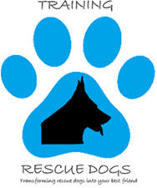
1626 Belle View Blvd., PO Box 7084, Alexandria, VA 22307 – 202-350-1149 – info@trainingrescues.org – www.trainingrescues.org

Animal Intake Policy
To provide training and rehabilitation to German Shepherd rescue dogs. We are committed to working with owner surrenders, other rescues, and shelters to identify German Shepherds who need rehabilitation and then provide funding for their training. Training Rescue Dogs will locate and hire competent, experienced trainers who will evaluate and rehabilitate these dogs so they will successfully transition into homes where they can thrive. Training and rehabilitation for these dogs is an unmet need among most animal rescues and shelters. We are fulfilling this unmet need.

