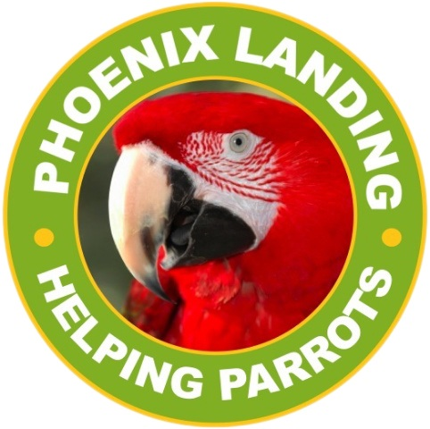
Phoenix Landing Foundation
P.O. Box 459
Alexander, NC 28701
phoenixlanding.org
contact@phoenixlanding.org

January 14, 2026

Intake policy for Phoenix Landing for 2025:

Parrots are surrendered to Phoenix Landing for re-homing. They come to us via owner surrender, in-state and out-of-state releasing agencies, or sometimes found loose outside.

