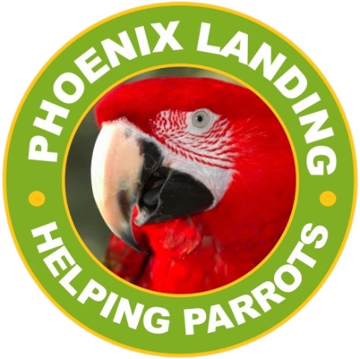**Phoenix Landing Foundation**  
P.O. Box 459  
Alexander, NC 28701  
phoenixlanding.org  
contact@phoenixlanding.org

December 31, 2023

Intake policy for Phoenix Landing for 2023:

Parrots are surrendered to Phoenix Landing for re-homing. They come to us via owner surrender, in-state and out-of-state releasing agencies, or sometimes found loose outside.