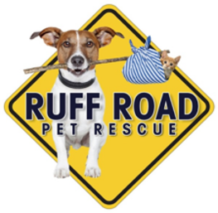
Ruff Road Pet Rescue
A 501 (c) (3) Corporation
Hollie Collins, President
Eileen Jewett, Kaytlynn Heroux, and Jamie Rolison, Directors

Intake Policy

Our Goal is to assist underprivileged pets find loving, forever families.

When Ruff Road is notified that a feline or canine is in need of a home, the Board of Directors
will vote on accepting the animal into the rescue. A vote of ¾ will be required to accept the
animal. The Board may take several considerations into account when deciding to accept the
animal. These include, but are not limited to personality, behavior, health, likelihood of being
adopted, and financial ability of the Rescue to provide care, etc. The decision to accept the
animal will be decided solely by the Board of Directors.

