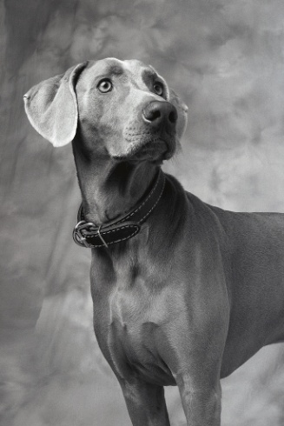
DC Area Weimaraner Rescue
1477 Hillandale Road
Front Royal, VA 22630
703 220-7334
dcweimrescue@gmail.com

Animal Intake Policy
The Rescue will intake Weimaraner dogs from shelters in the following states: Virginia, Maryland, Washington DC, West Virginia and Tennessee. If requested, other states may be included.
The Rescue will intake Owner Surrenders from the following states: Virginia, Maryland, Washington DC, West Virginia and Tennessee.
The Rescue will not take dogs with a bite history. All dogs will be evaluated and vetted prior to placement in a foster or adoptive home.

