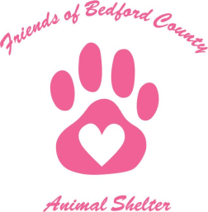

Friends of Bedford County Animal Shelter, Inc. (FOBCAS)

Intake Policies:

FOBCAS primarily takes in animals from the Bedford County Animal Shelter in Bedford VA. On a case by case basis we will accept domestic pets from Bedford County Residents who are in need of our assisitance.

Each animal pulled from the shelter must be assessed by a designated FOBCAS volunteer. Assessment results will have to be approved by the President. FOBCAS will require a copy of shelter medical log and any medical records at time of transfer. Bite cases or reported aggression issues will be reviewed on an individual bases and decided on by the Board of Directors.

All newly rescued pets will be flea treated and dewormed immediately.

If the new intake is not current on vaccines and heartworm tested or FIV/FELV tested, this must be done before going to the designated foster home when possible. If this is not possible due to veterinary hours or animal health the animal must be quarantined from the foster’s personal pets and other FOBCAS animals in their care until made current.

If the sterilization is not already done, each new intake will be altered in a timely manner depending on factors like heath and age. No animal will be released to an adopted home until altered.