 | 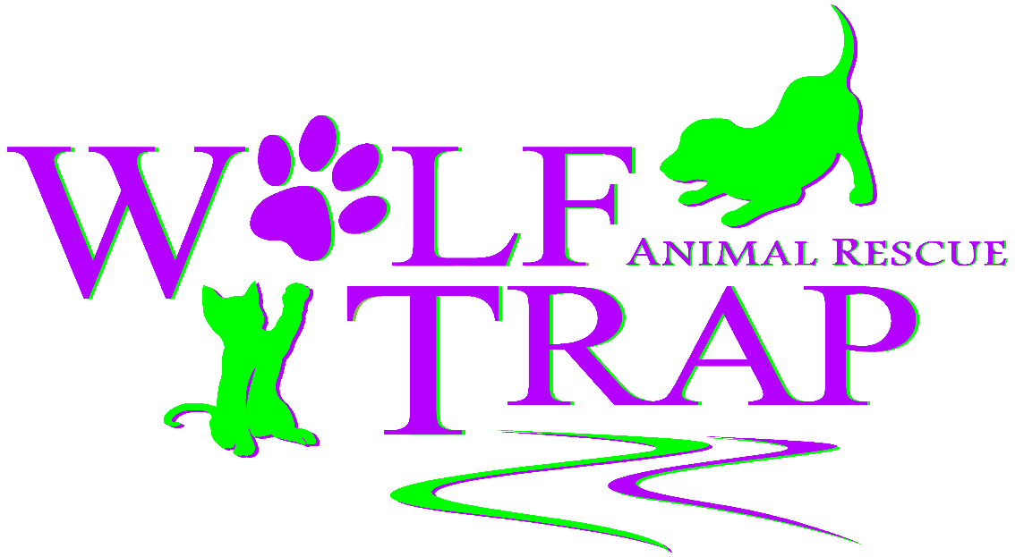
 | 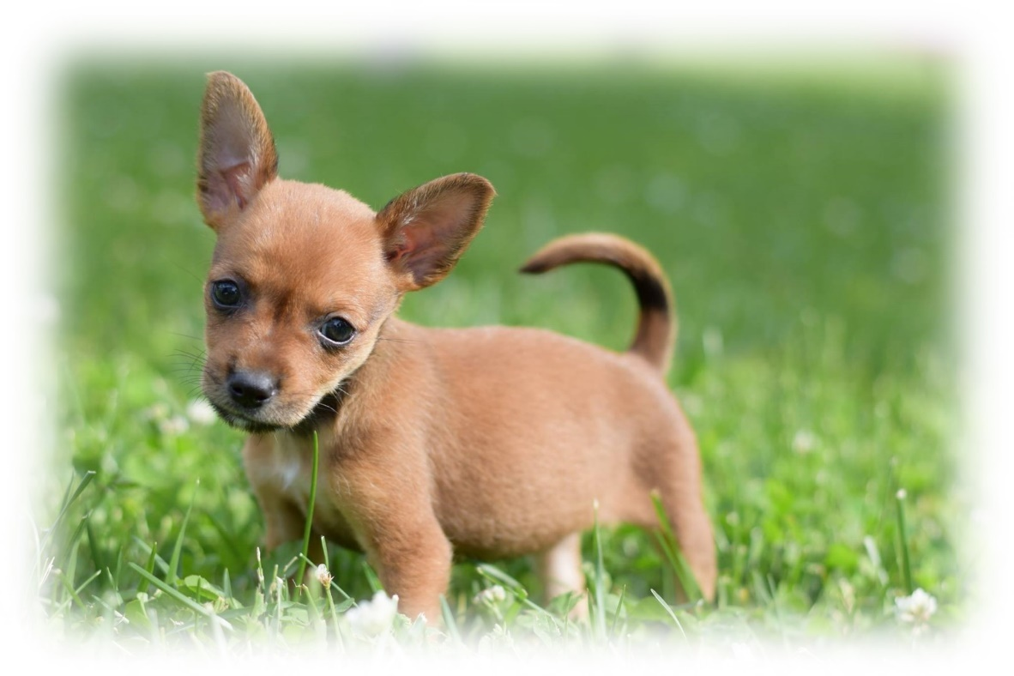
10/1/2016 | RESCUE TRANSPORT PROGRAM, INTAKE, AND TREATMENT PROTOCOLS
 | THESE PROTOCOLS ARE ENACTED TO FACILITATE BEST STANDARD OF CARE PRACTICES FOR TRANSPORT AND HEALTH INTAKE PROCESSES OF LARGE SCALE ANIMAL RESCUE EFFORTS.

Contents
RESCUE TRANSORT PROGRAM 2
RESCUE TRANSORT PROGRAM REQUIREMENTS 2
CANINES 2
FELINES 3
TRANSPORT PROTOCOLS 3
VEHICLE 3
ANIMAL CARE 3
ANIMAL INTAKE PROTOCOL 4
HANDLING 4
INTAKE STATIONS 5
ANIMAL IDENTIFICATION (STATION 1) 5
VETERINARY EXAMINATION (STATION 2) 5
TREATMENT (STATION 3) 8
FOSTER ASSIGNMENT (STATION 4) 8
NAIL TRIM (STATION 5) 8
WIPE DOWN/BATHE (STATION 6) 8
HARNESS FITTING (STATION 7) 8
FOOD, WATER, AND WALK (STATION 8) 8

Wolf Trap Animal Rescue
WTAR’s rescue transport program acts as a life-saving partnership with animal shelters in situations requiring immediate need of transport in order to reduce the risk of euthanasia.

RESCUE TRANSORT PROGRAM
- Once an animal has been accepted on WTAR’s transport vehicle, ownership of the animal will be transferred to WTAR.
- Animals will undergo intake health examinations performed by a licensed Veterinarian immediately upon arrival, and will be spayed/neutered prior to adoption.
- Each animal transferred into WTAR’s adoption program will undergo a minimum 14 day(s) quarantine period in order to provide human enrichment a well as to assess the health & behavior of the animal in WTAR’s foster care program.
- The source shelter must act in good faith to transport pets that meet the below requirements and the destination shelter’s requirements/restrictions.

RESCUE TRANSORT PROGRAM REQUIREMENTS
- Current copy of license from state municipal organization or 501(c)3.
- Notification to WTAR of any possible exposure to disease &/or outbreaks at your facility.
- All partners located out of the state of Virginia are required to have an Interstate Health Certificate by a licensed Veterinarian for each animal within 10 days prior to transport.
  - Animals over the age of 16 weeks must have proof of Rabies Vaccine
- Completed Transport List must be emailed to the Transport Coordinator no later than 12 hours prior to transport.
- All animals must be considered healthy, adoptable, and free from any known exposure to disease.
- All animals must have a visible and proper form of identification during transport at all times (collars, ID tags, etc).
- Clearly written health records that describe health status and identification of animals (health certificate, rabies certificate and copy of shelter record) must accompany each animal.
- All animals must be approximately 8 weeks of age or older, per Virginia State Law.

CANINES
In addition to the above, we also require the following for CANINES:
- Must be vaccinated against Parvovirus and Distemper and travel with current medical records.
- 6 months of age and older:
  - Must be heartworm tested negative within 1 month of transport
  - Temperament tested: proven safe with cats, other dogs, and children
  - Must be pre-approved prior to transport to ensure adequate and humane space on transport

FELINES
In addition to the above, we also require the following for Felines:
- Every feline must be FIV/FeLV tested negative within 1 month of transport.
- Must be vaccinated with FVRCP.
Any dog or cat with previous history of aggression or bite incident will NOT be allowed into WTAR’s rescue program.
Special exceptions outside these requirements can be made, pending approval from WTAR’s Transport Coordinator prior to transport. Our Transfer Partners will be notified immediately if any of the above listed rescue requirements are changed.

TRANSPORT PROTOCOL
At this point in time, WTAR utilizes Enterprise cargo rental vans in order to facilitate transport operations. All vehicles and animal enclosures will follow basic standards of care for animal transport.
WTAR’s goal is to humanely rescue as many lives as possible with each transport.

VEHICLE
- Must be able to provide environmental protection and adequate ventilation at all times.
  - Fresh air, free of exhaust fumes.
- Crates and cages are to be transported in a manner that reduces animal stress and discomfort.
  - Each animal must be able to stand, sit erect, lay down, and turn around comfortably.
  - All wire cages must have adequate bed pans and coverings to ensure comfort and prevent any waste material from exiting cages.
- Ambient temperature should be kept above 60°F (15.5°C) and below 80°F (26.6°C).
  - A thermometer will be placed at a visible location at the level of the animals in order to ensure adequate temperature control.

ANIMAL CARE
- All personnel must wear gloves while handling/transferring animals.
  - Gloves must be changed between each original destination cage/carrier when unloading and transferring to WTAR cage/carrier.
- If more than one animal per cage/carrier is required for transport, only designated littermates or kennelmates of originating shelter can be co-housed on transport.
- If young/nursing animals are accompanied by mothers, animals should be transported with the mother in a space large enough for her to lie down on her side with legs extended for comfort and to facilitate nursing.
  - If transported in a wire crate, place a thin sheet over crate in order to reduce stress for mothers (ensuring not to compromise air flow).
- Species/breed specific placement of cages/carriers
  - Cats should be located as separate as possible from dogs on transport due to increased sensitivity to stress.
  - Brachycephalic breeds (Short-nosed breeds such as bulldogs, pugs, boxers, etc) should be placed as close to air circulation as possible due to increased risk of stress-induced respiratory distress.
- Maintain sanitary conditions and replace protective absorbent pads during observation stops if needed.
- Animals must be observed and allowed rest every 4-6 hours.
- Water must be offered during each observation period (4-6 hours).
- Animal supply list:
  - Cleaning Materials: paper towels, chlorox bleach wipes, pet wipes
  - Slip-leashes, collars
  - Towels, blankets, sheets (if necessary)
  - Plastic bags for garbage
  - Accel wipes
  - Both dry & wet dog food
  - Nutracal

ANIMAL INTAKE PROTOCOL
Once animals arrive to a designated location, each animal undergoes a medical health examination and record evaluation by a licensed veterinarian to ensure any potential illness and/or condition is identified and promptly treated. Intake examinations require the participation of many volunteers, so the enforcement of protocols by key personnel are crucial in maintaining a bio-secure environment. This intake protocol institutes best standard of care practices in order to maintain biosecurity during large scale animal rescue transports.

HANDLING
- Animal Intake Facilitator
  - Each animal is gently removed from carrier/crate one at a time, by a designated volunteer (“Animal Intake Facilitator”).
  - This person will change gloves in between each carrier/crate. The animal is then handed to a designated volunteer (“Animal Handler”).
  - This person will wear a protective isolation gown and be cautious as to not allow contact to gown. If contact is made, Intake Facilitator will change gowns.

- Animal Handler
  - This person is assigned a specific animal to walk through each “Intake Station” until successfully reaching the final station.
  - Each animal handler will wear gloves and a protective isolation gown. Each gown/gloves will be changed in between each assigned puppy throughout the intake process.

INTAKE STATIONS
The animal intake process is made up of multiple “Intake Stations”, that have one or multiple assigned volunteers at each station. Each station provides a medical need or service needed to complete the entire rescue animal evaluation.

ANIMAL IDENTIFICATION (STATION 1)
- Animal is matched with its current medical records from transport shelter.
- Each animal is assigned to a foster home
- Identification collar replaced with clean, new collar. Each collar has the following information for foster reference:
  - Name
  - Breed
  - Age
  - Sex

VETERINARY EXAMINATION (STATION 2) 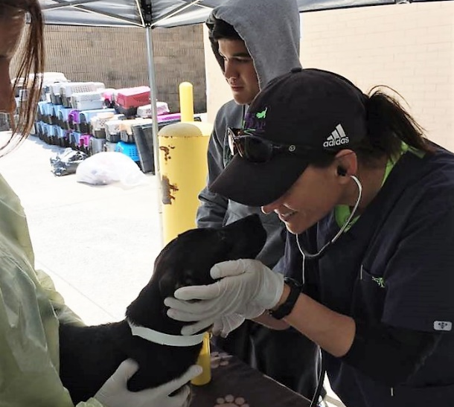
Each animal is given a comprehensive Veterinary medical examination by a licensed Veterinarian. Correct interpretation & evaluation of each animals’ medical records from the original shelter, along with physical exam findings, results in administering and performing the appropriate vaccinations and diagnostic tests.
It is important the initial station is for the Veterinary Examination in order to identify potentially infectious animals before they move on to other stations.

Physical Examination
The physical exam is performed on a portable table with a solid, flat surface. Each table is wiped down with Accel® disposable wipes between each animal examination.
- Temperature, Pulse, Respiration (TPR)
  - Disposable gloves are to be worn and changed in between each animal.
  - Temperature taken rectally with disposable cover slips.
    - Each slip is discarded and changed between each animal.
  - Stethoscope wiped clean with Accel® wipes after auscultation between each animal.
- Oral Examination – evaluate if age on record is reflective with dental eruption of deciduous teeth/canines
  - Mucous membranes
  - Capillary Refill Time
- Eye Exam – evaluate for any signs of ocular discharge/conjunctivitis
- Evaluate for nasal discharge
- Check ears for signs of infection and/or debri
- Evaluate hydration status - skin tint
- Tracheal Palpation – trachea is gently palpated to try and elicit a cough
  - Potential indicator for Kennel Cough
- Skin/Coat – evaluated for hair loss, wounds, ectoparasites
- Check spay/neuter status – mark record as intact or previously spay/neutered
- Scan for Microchip
  - If microchip present, verify with medical record accompanying animal
  - If no microchip, insert new microchip with WTAR information and attach to animals medical record.

Record Evaluation, Vaccination, & Mandatory Diagnostic Testing
Evaluation of records should be performed to better understand the immune status of each animal, as well as the relevant risk of animal and disease exposure. Diagnostic tests are performed to identify any potential underlying diseases, as well as to better understand the overall health of the animal. Any diagnostic test must be performed and interpreted by a licensed Veterinarian or Veterinary Technician under the Direct Supervision of a licensed Veterinarian before any results are recorded into the medical record.

CANINE VACCINE PROTOCOLS
- ≤ 4 months (16 weeks) of age:
- Determine if DA2PP (CD VIRUS, CAV-1, CAV-2, CPI VIRUS, CPiV AND CPV-2C) vaccine administered within past two weeks from originating shelter.
  - If ≥ 2 weeks since last vaccine, administer 1 dose DA2PP (VANGARD®5) booster vaccine.
    - If adopted immediately after 2 week quarantine period, recommend to adopters to booster vaccination within 1-2 weeks from adoption date.
    - If not adopted immediately following 14 day quarantine, administer booster vaccine 3-4 weeks from intake date.
  - If ≤ 2 weeks since last vaccine, do not administer DA2PP vaccine.
    - If adopted after 14 day quarantine period, recommend to adopters to booster vaccination 1-2 weeks from adoption date (pending date of recent vaccination).
    - If not adopted immediately following 14 day quarantine, booster vaccine at 3-4 weeks from most recent DAPP vaccination.

- ≥ 4 months (16 weeks) of age:
  - Verify completion of DA2PP vaccination series (at least two vaccinations administered within 3-4 weeks apart).
    - If vaccination series complete, do not vaccinate for DA2PP.
    - If no vaccination series completed, administer 1 dose DA2PP (VANGARD®5) vaccine subcutaneously with MLV vaccine in right shoulder.
      - If adopted immediately after 14 day quarantine period, recommend to adopters to booster vaccination within 1-2 weeks from adoption date.
      - If not adopted immediately following 14 day quarantine, administer booster vaccine 3-4 weeks from intake date.
  - Verify Rabies Vaccine given within 12 months & accompanied by Rabies certificate.
    - If no Rabies Vaccine certificate or documentation, administer killed Rabies Vaccine subcutaneously in right hind leg

- ≥ 6 months (24 weeks) of age:
  - Verify that dog tested negative for heartworm within 1 month of transport from original shelter.
    - If previous record indicates heartworm test result negative, do not repeat heartworm test.
    - If previous record indicates heartworm test result positive, repeat heartworm test to confirm diagnosis.
    - If no previous record of heartworm test, perform heartworm test and record results.

FELINE VACCINE PROTOCOLS
- ≤ 4 months (16 weeks) of age:
- Determine if FVCP (Feline Viral Rhinotracheitis Calicivirus Panleukopenia) vaccine administered within past two weeks from originating shelter.
  - If ≥ 2 weeks since last vaccine, administer 1 dose FVRCP(FELOCELL®4) booster vaccine.
    - If adopted immediately after 2 week quarantine period, recommend to adopters to booster vaccination within 1-2 weeks from adoption date.
    - If not adopted immediately following 14 day quarantine, administer booster vaccine 3-4 weeks from intake date.
  - If ≤ 2 weeks since last vaccine, do not administer FVRCP vaccine.
    - If adopted after 14 day quarantine period, recommend to adopters to booster vaccination within 1-2 weeks from adoption date (pending date of recent vaccination).
    - If not adopted immediately following 14 day quarantine, booster vaccine at 3-4 weeks from most recent FVRCP vaccination.
- ≥ 4 months (16 weeks) of age:
  - Verify completion of FVRCP vaccination series (at least two vaccinations administered within 3-4 weeks apart).
    - If vaccination series complete, do not vaccinate for FVRCP.
    - If no vaccination series completed, administer 1 dose FVRCP+CHLAMYDIOSIS (FELOCELL®4) vaccine subcutaneously with MLV vaccine in right shoulder
      - If adopted immediately after 14 day quarantine period, recommend to adopters to booster vaccination within 1-2 weeks from adoption date.
      - If not adopted immediately following 14 day quarantine, administer booster vaccine 3-4 weeks from intake date.
  - Verify Rabies Vaccine given within 12 months & accompanied by Rabies certificate
    - If no Rabies Vaccine certificate, administer killed Rabies Vaccine subcutaneously in right hind leg
- All ages:
  - Verify that cat/kitten tested negative for FeLV/FIV within 1 month of transport from original shelter.
    - If previous record indicates FeLV/FIV test result negative, do not repeat FeLV/FIV test.
    - If previous record indicates FeLV/FIV test result positive, repeat FeLV/FIV test to confirm diagnosis.
    - If no previous record of FeLV/FIV test, perform FeLV/FIV test and record results.

TREATMENT (STATION 3)
Before each animal can be placed into a foster home, it must receive age and weight appropriate routine dewormer, flea/tick control, and heartworm prevention. Other treatments may be administered based on evaluation of animal per instruction by Veterinarian. Treatment is to be administered by a licensed Veterinarian or a Licensed Veterinary Technician under the Direct Supervision of a licensed Veterinarian.

Foster Assignment
Fosters are assigned based on preference indicated on appointment sign-up via acuity scheduler. If the foster requests more than one puppy for companionship, it must be a puppy/littermate that has been previously housed together at original shelter.
Foster assignment is given after the animal has passed a veterinary examination and has been medically cleared for fostering.

NAIL TRIM (STATION 5)

WIPE DOWN/BATHE (STATION 6)
*NOTE* IF ANIMAL IS HEAVILY SOILED – IT WILL SKIP STATIONS 1-5 AND GO STRAIGHT TO STATION 6. ONCE DRY, IT WILL RETURN TO STATION 1.

HARNESS FITTING (STATION 7)

FOOD, WATER, AND WALK (STATION 8)

