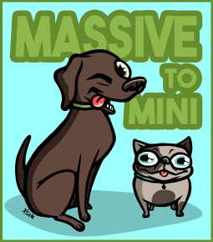

**Massive to Mini Animal Rescue Intake Policy**

Massive to Mini Animal Rescue is a small all-breed home based animal rescue. We accept dogs from Virginia Releasing Agencies, Out of State Releasing Agencies and private owner surrenders on a limited basis. We accept animals based on the availability of foster homes, type of dog that foster home can accommodate, availability of appropriate financial and veterinary resources to ensure proper care can be provided and other reasons as applicable. Massive to Mini Animal Rescue strives to help as many dogs as possible throughout the year, while being realistic about our resources as a small, local rescue.