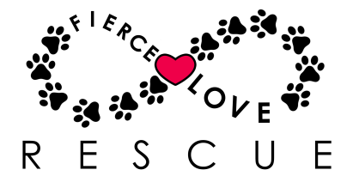
FLR Intake Policy
September 17, 2018

Introduction
The Intake Policy outlines the steps in FLR’s intake process, the information collected during intake, and why FLR may close intake temporarily. Each area is described below.

Intake Process Steps
The following steps are performed by the FLR Intake Team.

- Identify potential animals through shelters, rescues, strays, and owner surrenders.
- Temperament-test the animal (if appropriate for the species).
- Obtain all medical and transfer-of-ownership paperwork.
- Assign an FLR ID# to the animal.
- Transport the animal to the foster parent.
- Vet-check the animal.

Information Collected During Intake
Depending on the species and the animal’s route to FLR, the following information may be collected:

- Animal name
- FLR ID#
- Intake date
- Intake reason
- Gender
- Age
- Approximate weight
- Neuter/spay status
- Bite history
- Behavioral history
- Health Certificate (if coming from out-of-state)
- Veterinary records, including proof of rabies vaccination and rabies tag # (if issued)

Why FLR May Temporarily Close Intake
FLR regrets that sometimes we are unable to accommodate requests to sponsor animals. FLR does not have a facility – our animals are all in foster homes. If we do not have a foster home available or the necessary funds to care for the animal prior to adoption, we will turn down the request. Please note that sometimes we may close intake for one species while leaving intake open for others.

