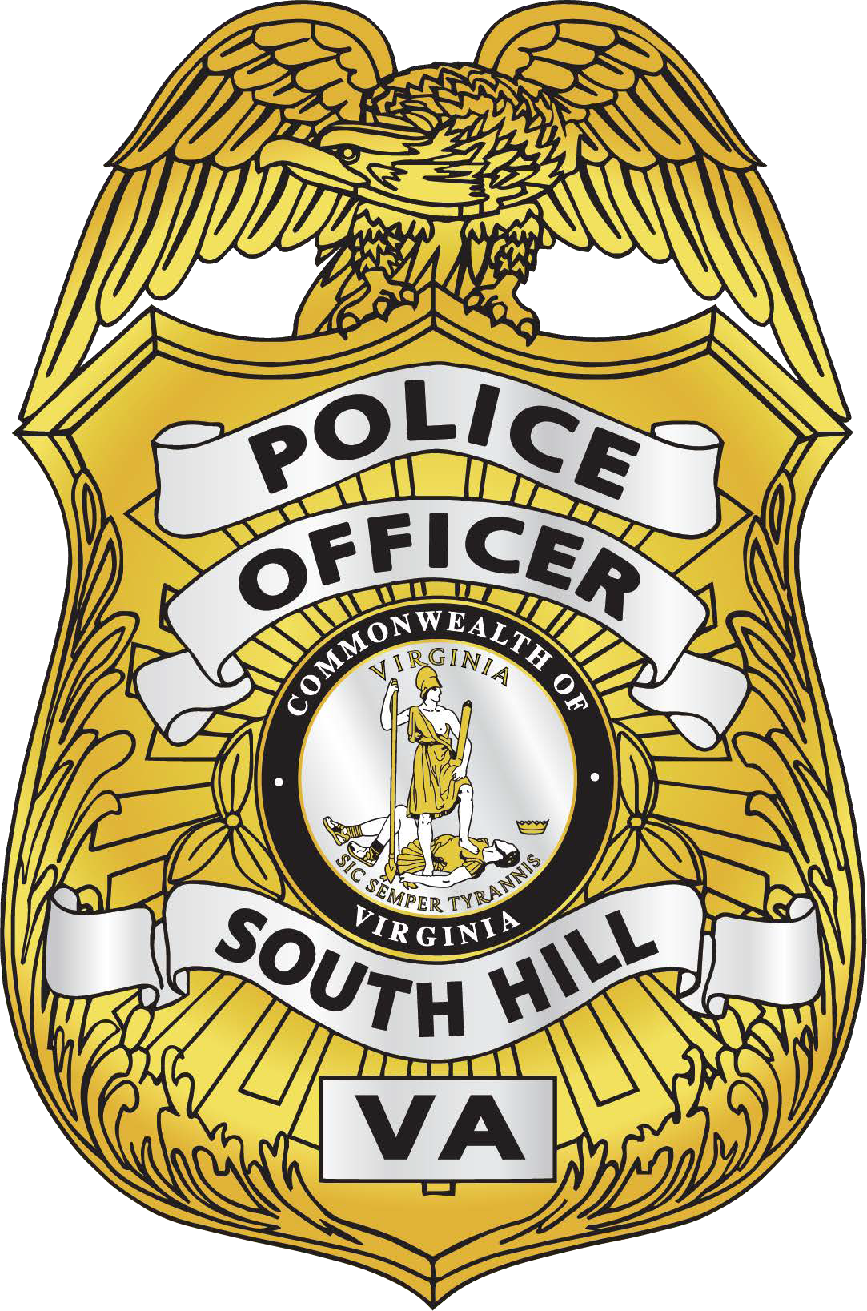


South Hill Police Department
103 S. Brunswick Avenue South Hill, Virginia 23970

434-447-3104
Service
Honor
Pride
434-955-2101
Dedication

