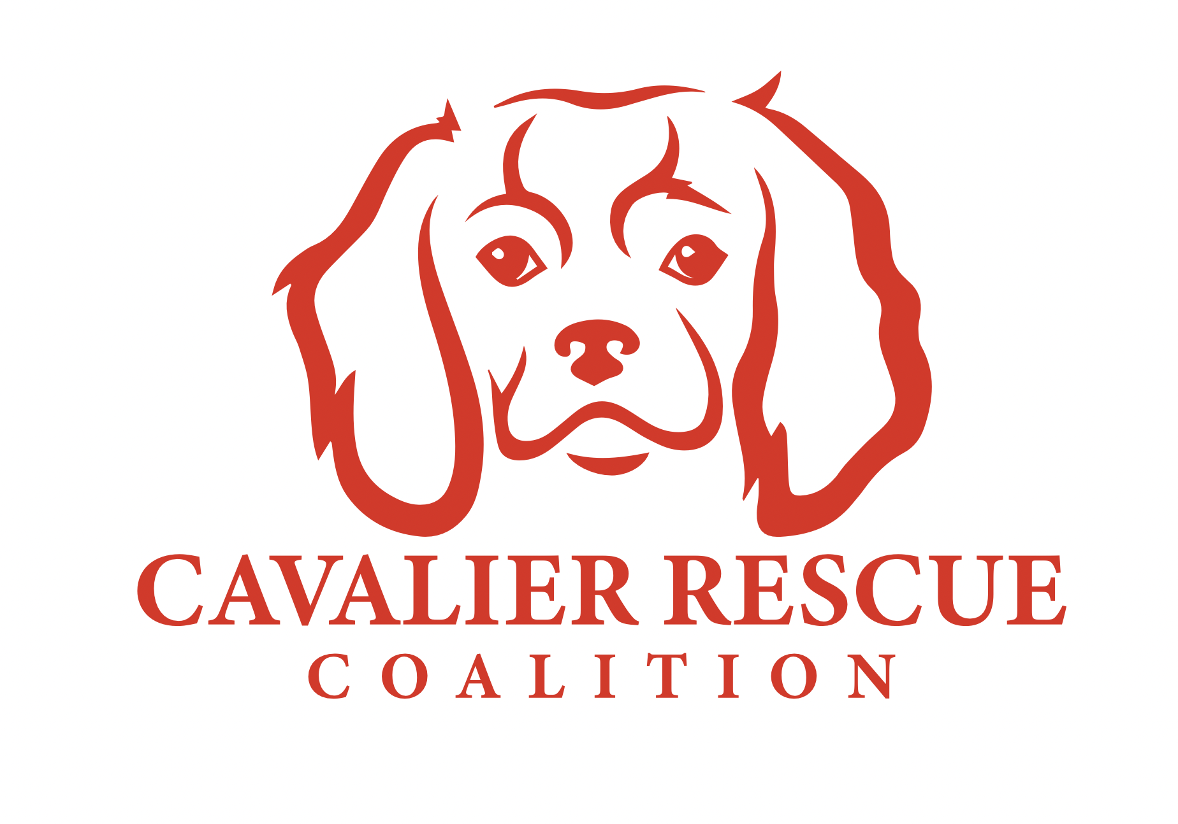

**Intake Policy**

Cavalier Rescue Coalition’s mission is to take in Cavalier King Charles Spaniels and Cavalier King Charles Spaniel mixes (ie. Cavapoo, Cavachon, etc) from private owners, breeders, puppy mills and animal shelters.

While we focus on seniors and special needs, we accept all Cavaliers and Cavalier Mixes into our rescue program.