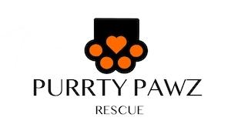

**INTAKE POLICY**

Purrty Pawz Rescue Inc. has a strict no-kill policy; which means that we will not euthanize animals, except if the animal is suffering and there is no hope for recovery. All animals are in dedicated, qualified foster homes for as long as necessary until adopted by a qualified applicant.

Purrty Pawz Rescue Inc. focus is our unsheltered community cats however if we have an available foster we will intake pets from community members that are in need of rehoming their pet and shelters/rescues. Our intake policy is as follows:

1. Fill out a surrender form
2. Must be up to date on vaccines
3. Cats must have FeLV/FIV test results at time of Intake (must be within 30 days of Intake)
4. All medical records must be turned over at time of Intake
5. Medical evaluation completed before time of intake (must be within 30 days of Intake)
6. Dogs must be on a leash

We strive to take as many animals as possible, but have a limited number of fosters. Therefore we use Petfinder and our social media platforms to help get pets adopted so we can intake more.

Purrty Pawz Rescue Inc. strongly recommends the spaying and neutering of dogs and cats in order to reduce the number of unwanted or surrendered pets in our area.

We do require a surrender fee