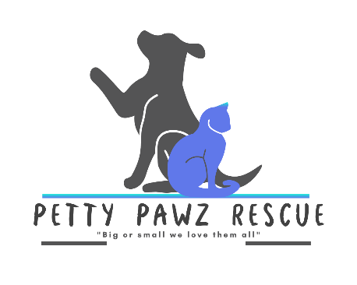
Petty Pawz Rescue Intake Policy

Petty Pawz Rescue has a strict no-kill policy, which means that we will not euthanize animals, except if the animal is suffering and there is no hope for recovery as determined by a veterinarian. All animals are in dedicated, qualified foster homes for as long as necessary until adopted by a qualified applicant.

Petty Pawz Rescue intake policy is as follows:

- Transfer from the local county shelter (kill facility) for animals in imminent danger,
- Transfer from the local county shelter (kill facility) as needed,
- Accept surrendered animals on a case-by-case basis,
- Transfer from other rescue agencies as needed,
- Pick up stray animals on very rare occasions after being scanned for microchips, posting as a found animal, and report to animal control.

We strive to take as many animals as possible but have a limited number of fosters available. Therefore, we hold or attend adoption events as much as we can and available animals are posted on Petfinder, Rescue Me, and Adopt a Pet, which automatically updates our website. We also post available animals to our Facebook page and other related social media platforms.

Petty Pawz Rescue strongly recommends the spaying and neutering of dogs and cats, to reduce the number of unwanted or surrendered pets in our area.

