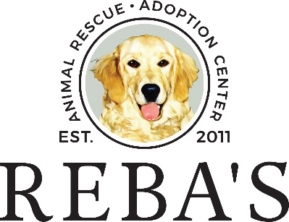
SOP: Intake of Animals
Effective 00/00/0000

- Type of animals accepted
Reba's Animal Rescue routinely accepts dogs and cats. Although we have occasionally accepted rabbits in the past, they are not a primary focus of our efforts. Currently, we do not accept wild animals, livestock, reptiles, fish, or similar species due to limitations in our facility's housing, resources, and trained staff for their care and placement.

- Transfer of animals from outside organizations
Reba's Animal Rescue accepts animals transferred from local municipal shelters in the Greater Hampton Roads region, as well as other municipal shelters, private shelters, and rescue organizations both regionally and globally.

- Adoption Returns
Reba's Animal Rescue is dedicated to the welfare of all pets we place in homes and will always welcome back any pets adopted from our organization. If an adopter needs to return their pet, they should reach out to us, and our staff will gather pertinent information about the pet and the reason for the return. We will evaluate the situation and may provide resources to assist the adopter in keeping the pet if possible.

- Owner Surrendered Animals
Reba’s Animal Rescue may accept owner-surrendered animals from residents of the Greater Hampton Roads region and nearby counties on a case-by-case basis, as space allows. However, we encourage owners seeking rehoming services to utilize local community resources. We will do our best to provide referrals and alternatives to assist them during this process. Pets adopted from other local organizations should be returned to those agencies unless otherwise directed.
- Strays
All stray animals must be taken to the animal control agency for the city where they are discovered. If a citizen cannot transport the pet to the city agency, Reba's Animal Rescue may temporarily hold the animal until the city's animal control can pick it up. An exception can be made for unweaned kittens if a foster home is available. These intakes will be reported to the appropriate animal control agency, and the animals will be taken into custody with that agency's permission.

